

**University of Information Technology and science**

Depertment of CSE

**Assignment-03**

|  |  |
| --- | --- |
| Course Code | CSE0613112 |
| Course Title | Structured Programing Language Lab |
| Submission  Date | 17.03.2024 |

|  |  |
| --- | --- |
| Submitted by: | Submitted to: |
| Name: Saha Pradyumna Prasad  ID No: 0432410005101159  Batch: CSE 55th  Section: C | **Name: Tania Akter Setu(TAS)**  **Lecturer,Dept of CSE, UITS** |

* **Program No-03.A**
* **Program Name**: Maximum number among two numbers.
* **Introduction:**

Take two variables and use if.....else conditionand check greater than logic.

* **Methodology:**

Take two variables named num1 and num2.Then using the input from the user.Condition if num1>num2 then print num is greater than num2.else condition must print num2 is greater than num1.

* **Program Code:**

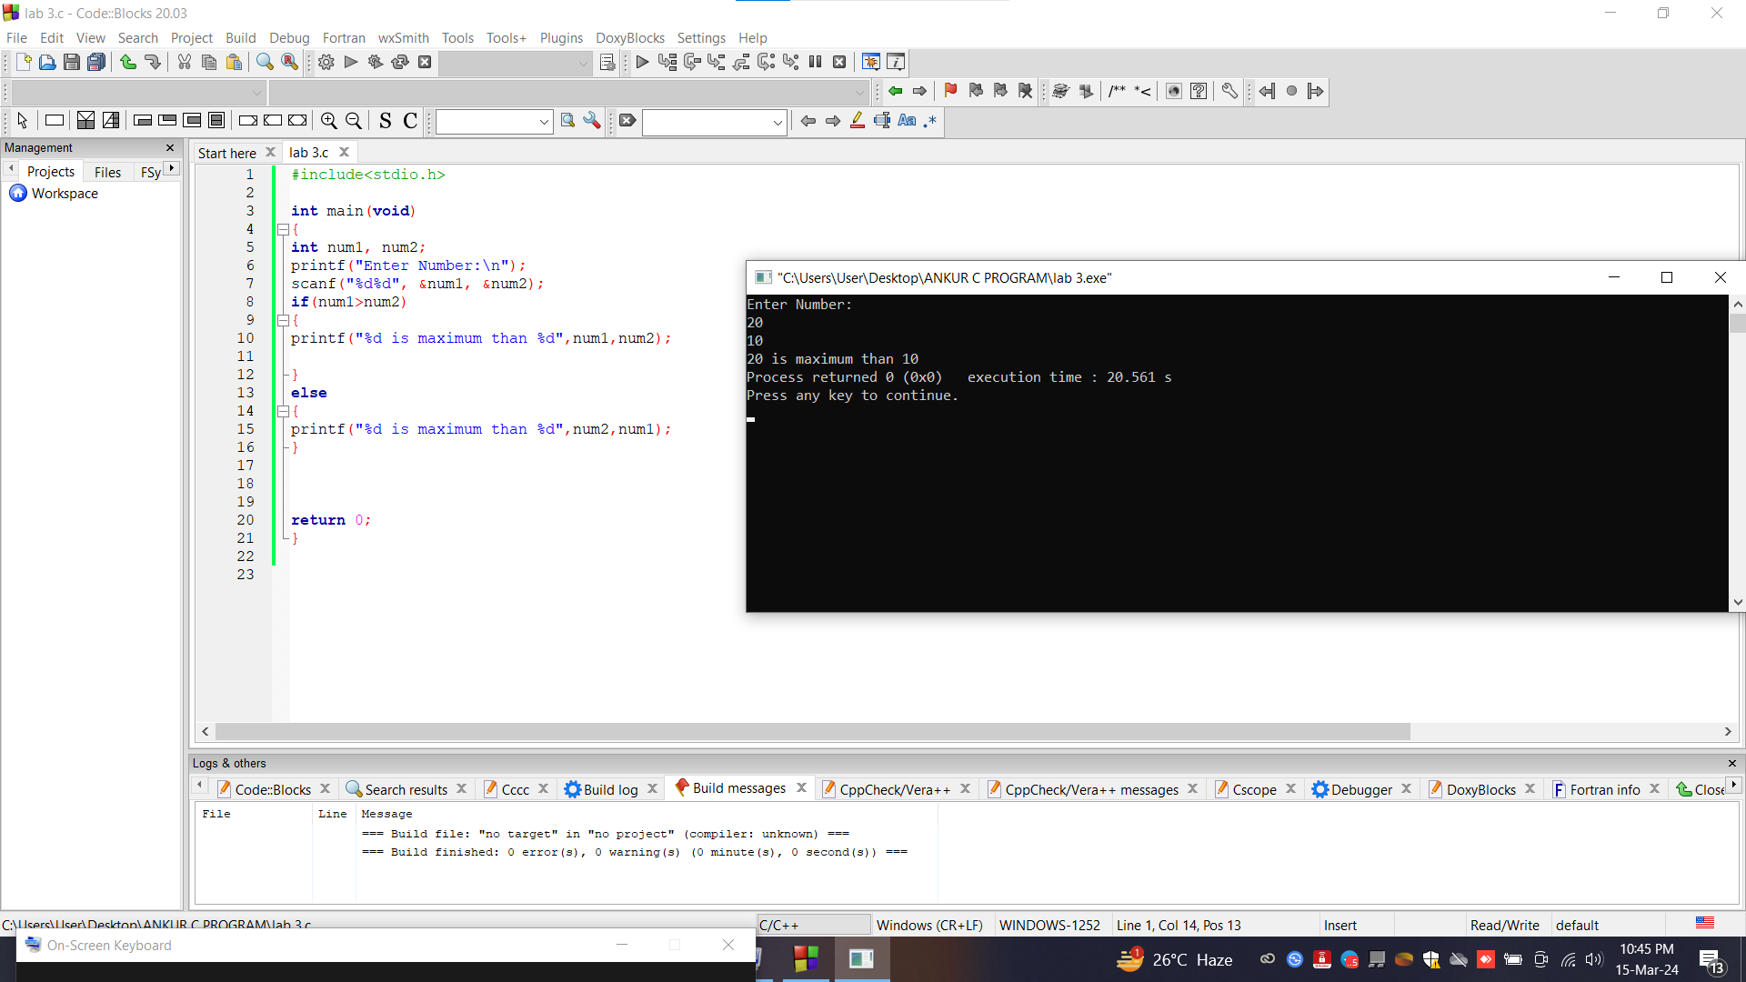

* **Conclusion**: The program runs successfully.
* **Program No-03.A**
* **Program Name**: Maximum number among three numbers.
* **Introduction:**

Take four variables with one assigned value and check if......else condition check with max number.

* **Methodology :**

Take three variables named num1,num2,num3 and max three variables inputs from users.then if condition used with logic num1>num2&&num1>num3 and assigned this value in max=num1.Then used else if with logics num2>num1&&num2>num3 and the values in max=num2.In the final logic with only else and assigned value and max=num3.

Finally, print the max value and program executed.

* **Program Code:** 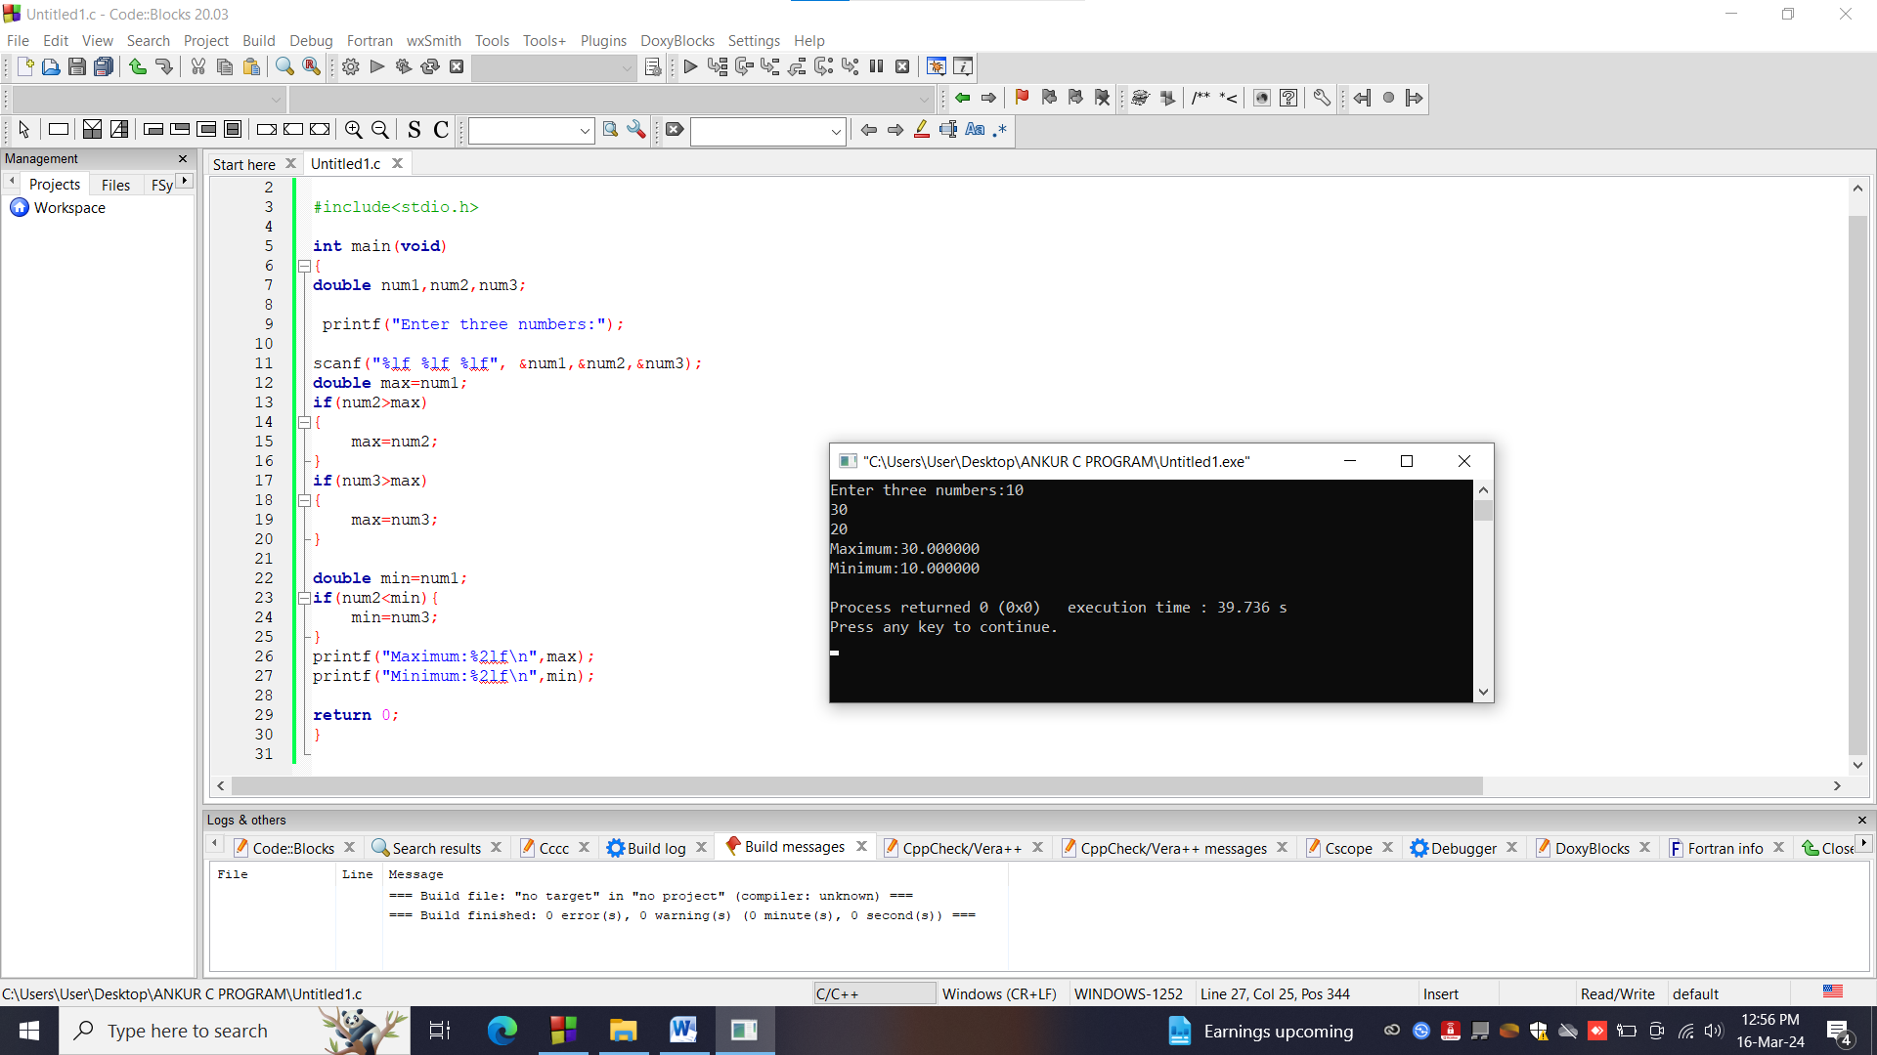
* **Conclusion:**The program runs successfully.